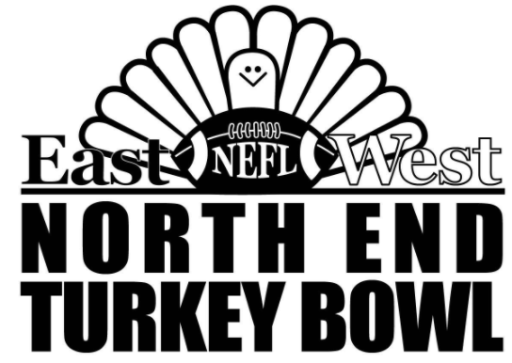

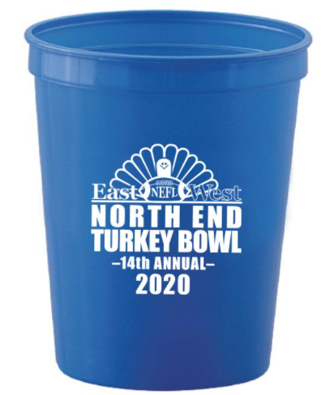



* **2021 Can Drive -**



**Help support the Soup Kitchen and those of our community in need this Thanksgiving**

|  |
| --- |
| **WHEN**  **Thursday, Thanksgiving Day**  **Turkey Bowl game time 9:30am – 12:00pm**  or after the game but before Saturday morning:  Jack Wolber’s house at 43 Berkeley St.  Jack Crisp’s house at 7 Bartlett Ave.  **WHERE**  Neighbor’s Field (corner of Elliott St. and Webster St.)  **WHAT TO DONATE**  Non-perishables, cans are preferred for handling reasons  Canned fruit, Canned vegetables  **CASH DONATIONS**  Also happily accepted  **COMMEMORATIVE CUPS**  We have this year’s commemorative cups for all  **HINT**  Cases of cans can be purchased from most of the local grocery stores |

**Your community and those less fortunate thank you!!**